Credit Score Logic Plan

Brian Veitch

Description: To determine what type of credit a user based on their credit score.

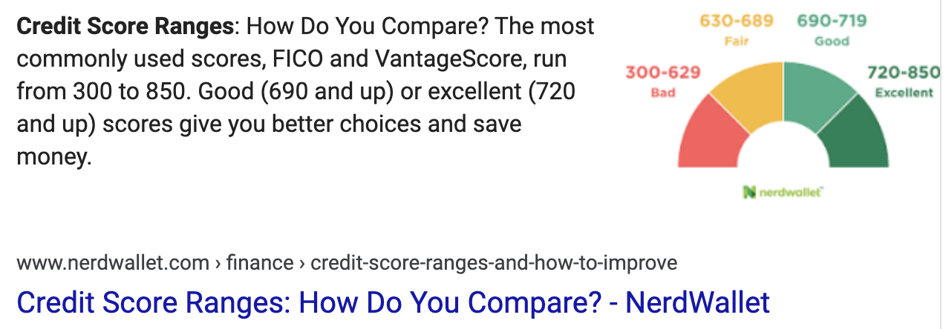

**Data:**

Variable and Input

* Credit_score: Int

Output:

* Credit_description: String (excellent, good, fair, bad)

**Proccessing:**

If credit_score >= 720 -> credit_description = excellent

Else if credit_score >= 690 -> credit_description = good

Else if credit_score >= 630 -> credit_description = fair

Else -> credit_description = bad

**Output:**

With a credit score of {credit_score} you have {credit_description} credit.